Marwadi University
Faculty of Computer Applications

BCA 4E Python Mid-1 Exam

Enrollment No. : 92400527004
Name : Utophiwa Mabuza
Class : BCA 4E
Date : 12 March 2026

Answer – 1
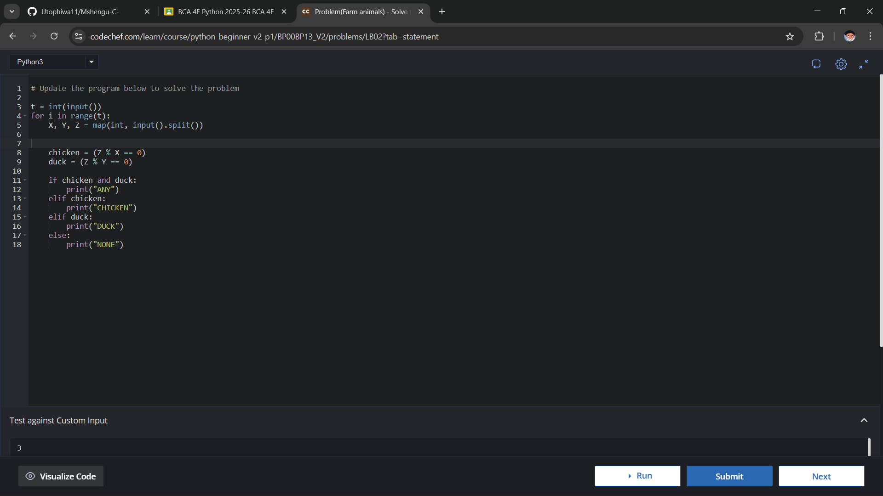
Answer – 2
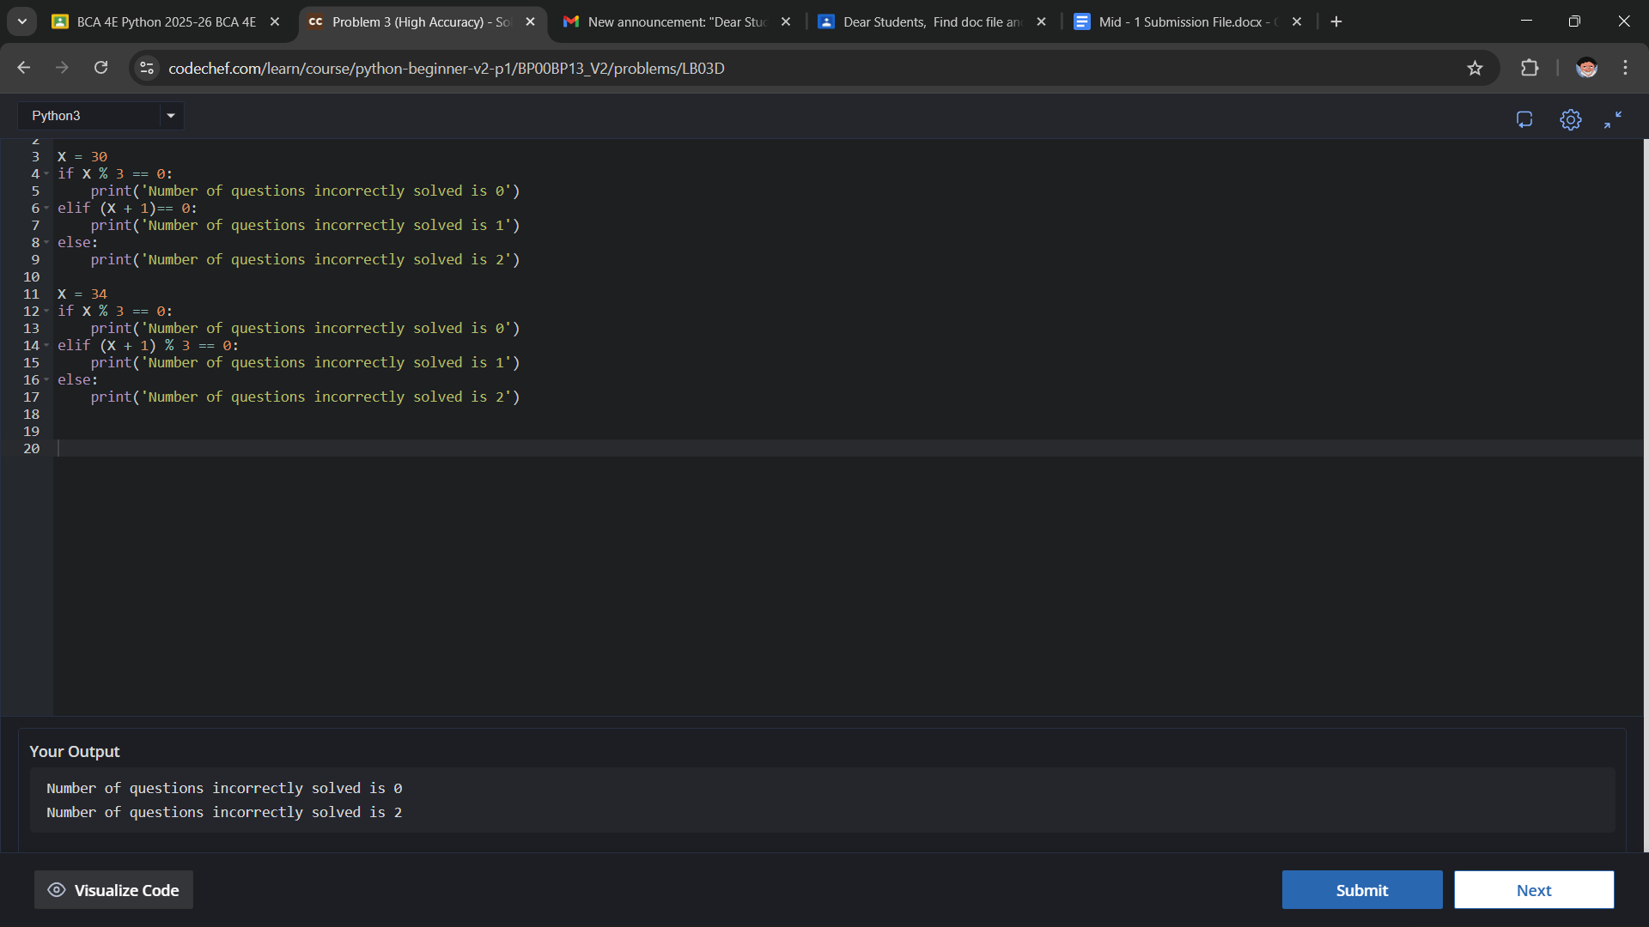

Answer – 3
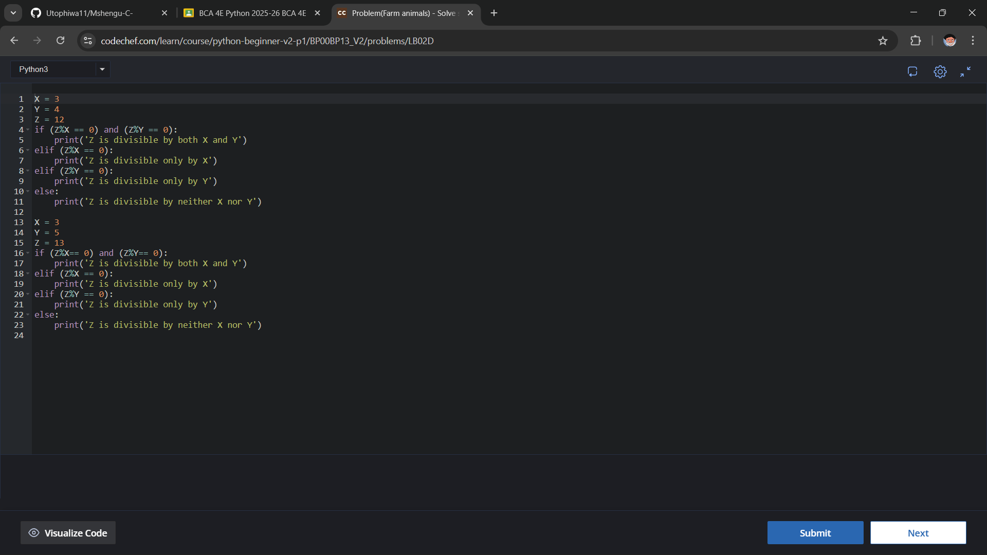
Answer – 4
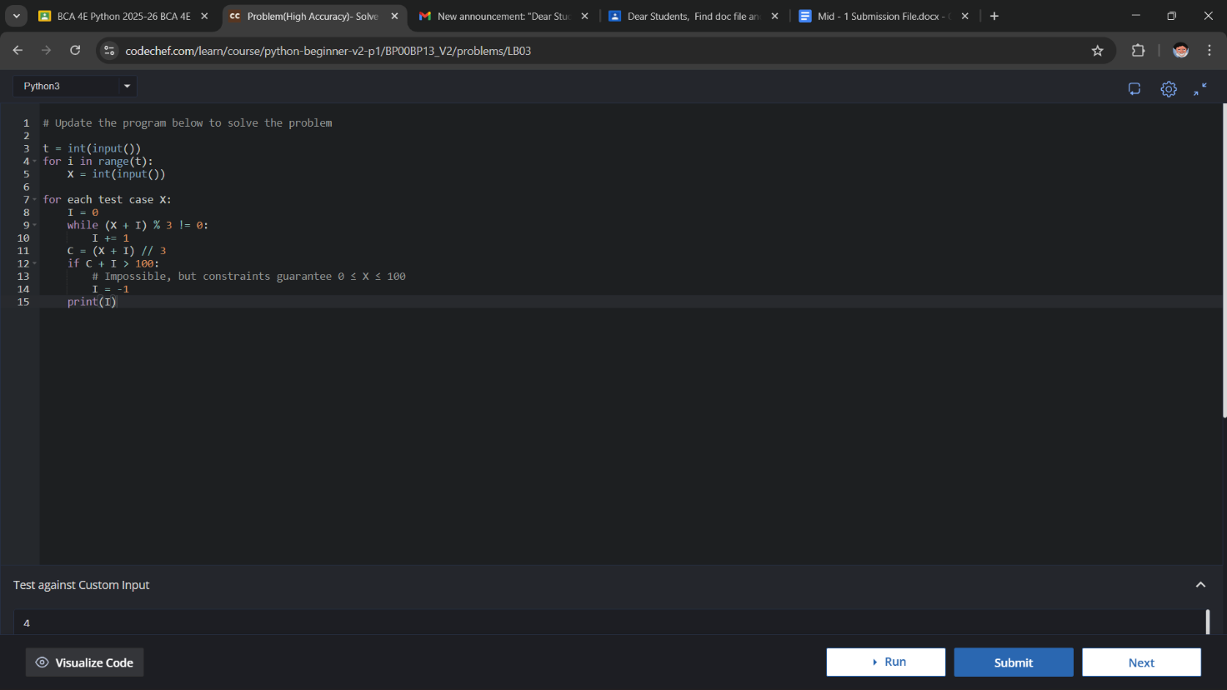

Answer - 5

